Day 1 Agenda :

OOAD, Maven

OOAD – Object Oriented Analysis Design – SE Methodology to Design System using OO Concepts

POP – Procedural Oriented Programming

OOAD

UML – Unified Modelling Lang - General Purpose Visual Modelling Lang

1. Use Case Diagram
2. Activity Diagram
3. Architecture Diagram
4. ER Diagram
5. Class Diagram
6. Flowcharts

Maven –

What – Maven is Project Management Tool (Build, Scan, Deploy, Dependency Management, Packaging, Testing)

Why – Building (Converting Source code to Byte Code), Testing, Packaging (Converting to a single jar/war/ear), Manage Dependency,

How

Download JDK8/11 if it is not already available in your system.

<https://www.oracle.com/in/java/technologies/downloads/#java8-windows>

Check the version of JAVA installed in your system, using the below command in command prompt.

“java -version”

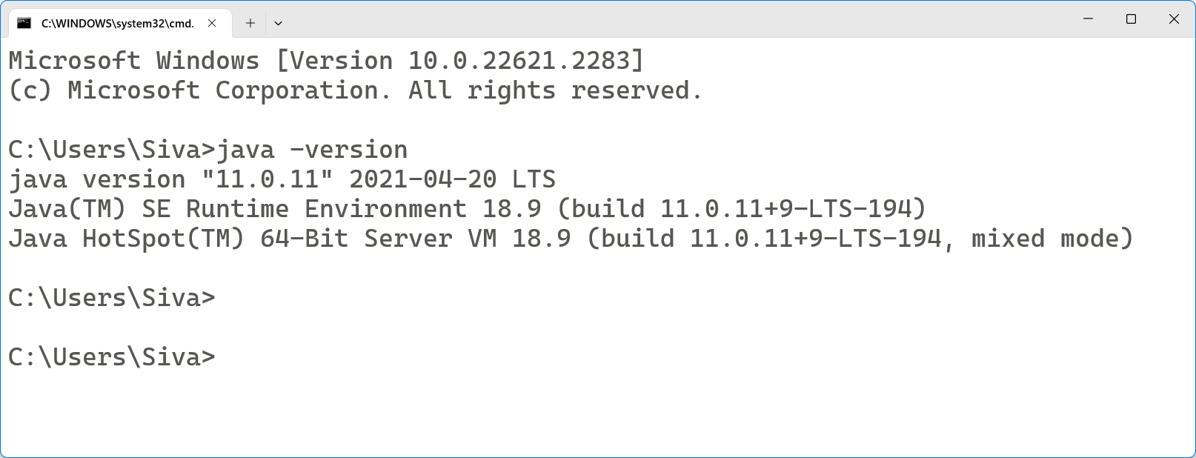

Manage Multiple versions of JAVA using Environment Variable

Add new environment variable “JAVA_HOME” if it is not there already.

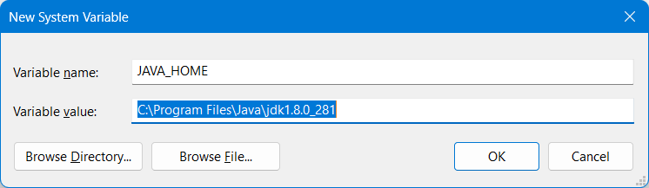

Modify the “path” environment variable to include this %JAVA_HOME%\bin and move it to top.

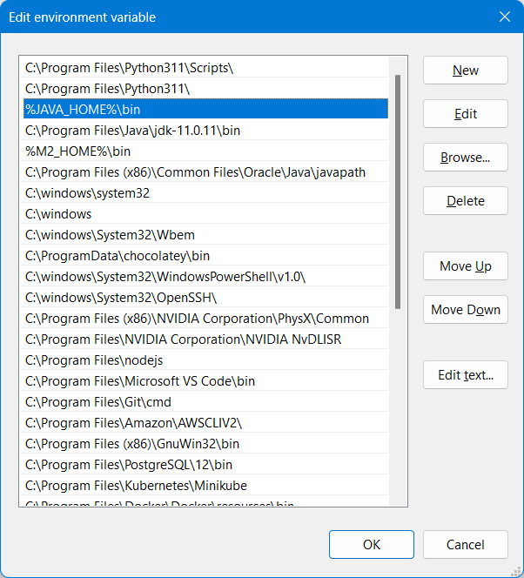

Download Maven Zip file from Official site

<https://maven.apache.org/download.cgi>

Extract the content to C drive

Then add “M2_HOME” to the environment variable

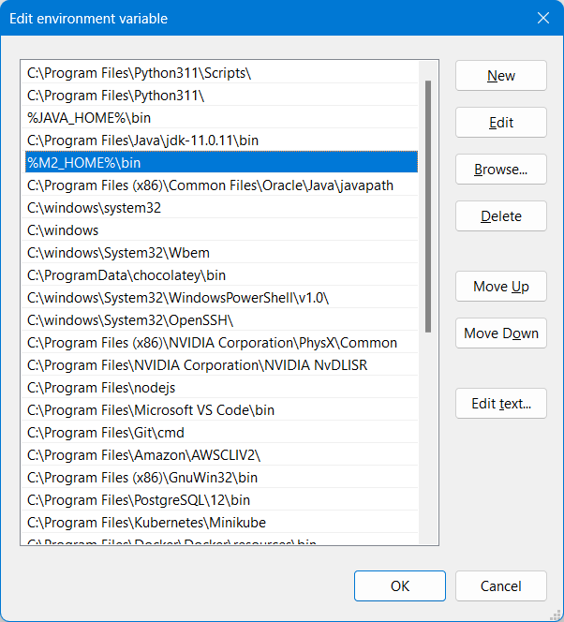

Confirm the maven version by using the following command

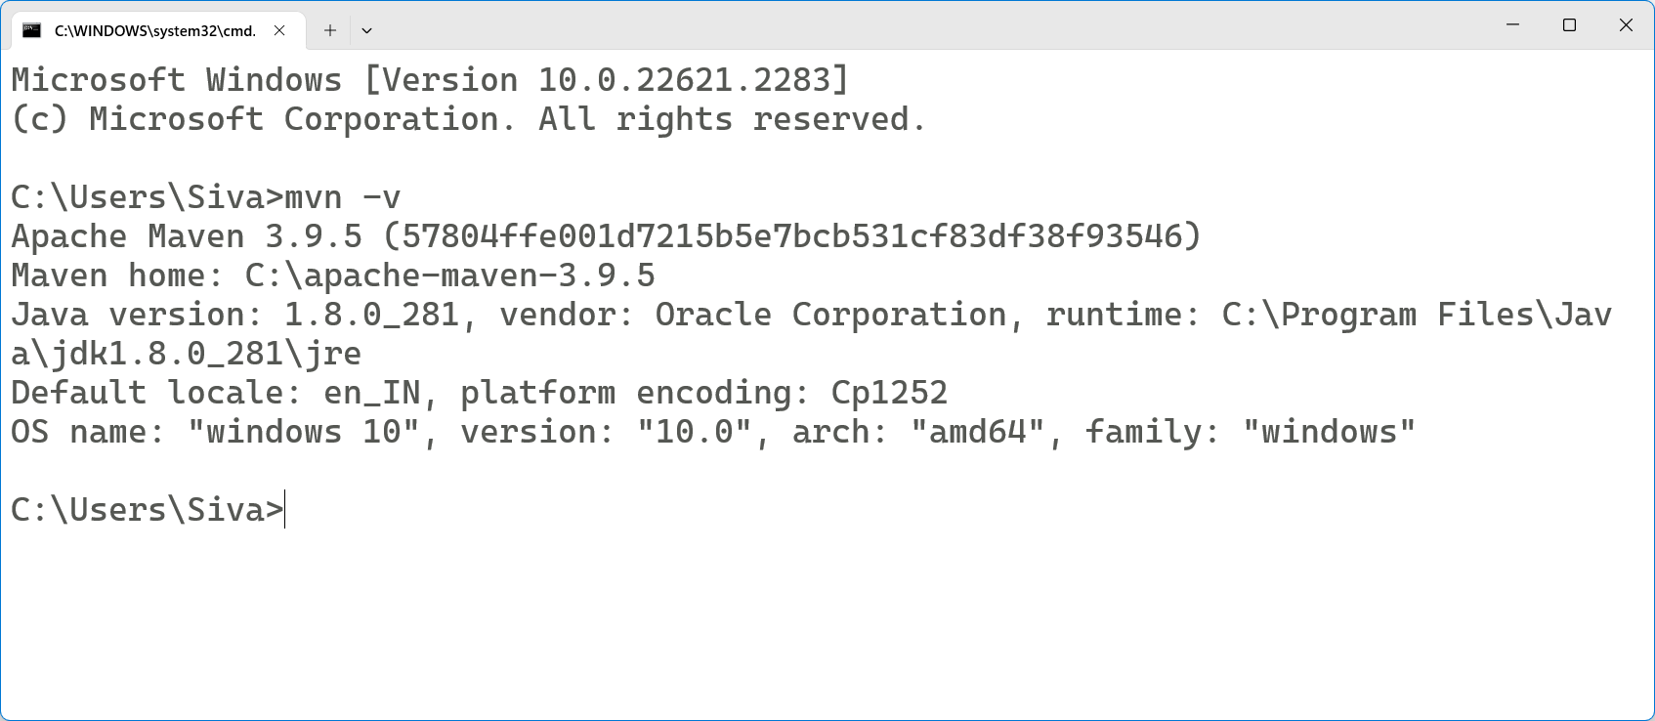

POM – Project Object Model

Backbone of Maven is pom.xml file (Configuration)

<groupId> (reverse of the company url) we follow package naming standards

<artifactId> name of the project

<version> 0.0.1